ASSIGNMENT (DATA ANALYTICS)

A

- Select the dataset to include in the bar chart.
- Go to Insert → Bar or Column Chart.
- Choose a chart type (Clustered Bar, Stacked Bar, etc.).
- The bar chart appears on the sheet.
- Add chart elements (titles, data labels, axes).
- Change colors or bar width using Format.
Create a line graph interpreting the data and mention the steps one by one

- • Open the Excel file containing your data.
- • Select the data range you want to plot (including headers).
- • Go to the Insert tab on the Ribbon.
- • In the Charts group, click Line Chart → choose a style (e.g., Line with Markers).
- • A line graph appears on the sheet.

Create a pie chart and interpret the result and mention stepwise procedure.

- Select the column containing categories and the corresponding values.
- Go to Insert → Pie Chart.
- Choose a chart type (2-D Pie, 3-D Pie, Doughnut).
- Add chart elements using the “+" symbol:
- Data Labels (Percentage, Category Name).
- Legends
Mention three Excel formulas and method of applying it, paste the formula along with both input and output
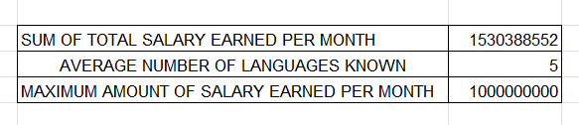
Apply statistics to any of the columns and interpret the findings.
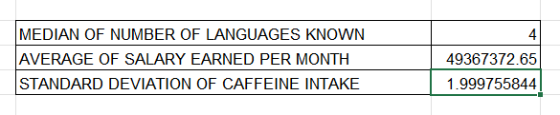
NAME : ALBIN REGI JOHN
REG NO. : 2462604
CLASS : 4BTELCS

